PAYMENT
Registration fee includes:
- Conference materials
- Participation in the confernce
- Dinners, coffee breaks, Gala Dinner

Deadline for registration | Full participation | Students  Ph.D. Students
Bank account number | 650 PLN | 300 PLN
From June 1st 2017 | 700 PLN | 350 PLN

Bank:
Citi Handlowy, Warsaw, o. Olsztyn, Poland
Bank account number:
IBAN: PL 20 1030 1986 2700 0000 1688 001
SWIFT: CITIPLPX

Account holder:
University of Warmia and-Mazury in Olsztyn
Oczapowskiego 2, 10-719 Olsztyn, Poland

Add information: Conference, name and surname of participant

In case of participation resignation after 15 August 2017 the fee will not be paid back.

ACCOMODATION

Conference fee does not cover costs of journey and accommodation.

Links to the hotels near to Conference location are accessible at the conference webpage

PROGRAMME

7.09.2017 10⁰⁰ – opening of the II PwIB conference
10³⁰ – 17⁰⁰ Conference
18³⁰ – Performance
19⁰⁰ – Gala Dinner
8.09.2017 9⁰⁰ – 12⁰⁰ Conference

On 8.09.2017 there will be opportunity to visit exhibition stalls of producers and institutions being active in support of OSH and property safety improvement.

HONORARY PATRONAGE

Conference will take place under the auspices of

prof. dr hab. Ryszard J. Górecki,
Rector of the University
of Warmia and Mazury in Olsztyn

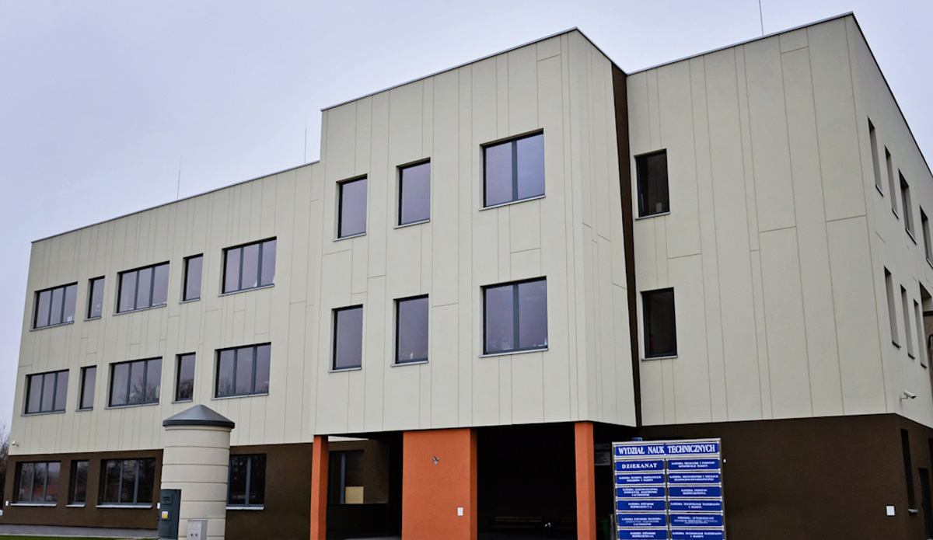

Secretariat
dr inż. Ewa Siemianowska
mgr inż. Agnieszka Barszcz
University of Warmia and Mazury in Olsztyn
Faculty of Technical Sciences
Chair of Foundations of Safety
Heweliusza 10, 10-724 Olsztyn, Poland
+48 89 524 56 15
+48 89 524 56 12
e-mail: konf.bezp@uwm.edu.pl

Medial Patronage



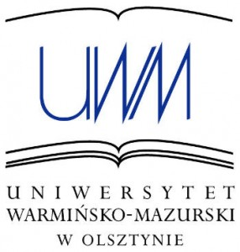
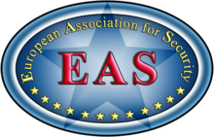



II International Conference in the series

ADVANCES IN SAFETY ENGINEERING

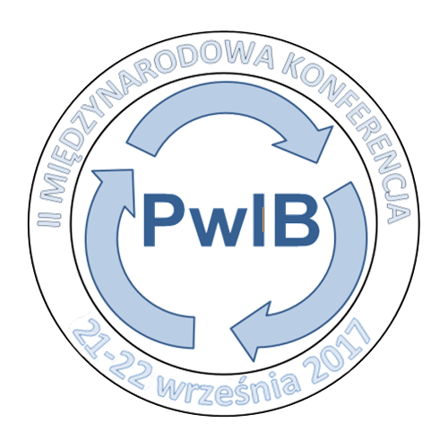

http://konfbezp.weebly.com

Conference will be held on 7 and 8 September 2017
in Hotel Park, Olsztyn, Poland

ORGANIZERS

Chair of Foundations of Safety,
University of Warmia and Mazury in Olsztyn
European Association for Security

CO-ORGANIZERS

Central Institute for Labour Protection –
National Research Institute,
Office of Technical Inspection,
National Labour Inspectorate,
Stowarzyszenie Inżynierów i Techników Mechaników Polskich






SCIENTIFIC COMMITTEE

prof. dr hab. Krystyna A. Skibniewska, UWM in Olsztyn (Polska) – president
prof. dr Vyatheslav Berezutskiy, National Technical University in Kharkov (Ukraine)– vice-president
prof. ndzw. dr hab. inż. Leszek F. Korzeniowski, European Association for Security – vice-president

dr hab. inż. Wioletta Bajdur, Częstochowa Technical University (Polska)
dr hab. inż. Elżbieta Bondar-Nowakowska, Wrocław University of Environmental and Life Sciences (Poland)
prof. dr Stanislavas Dadelo, Gedymin Technical University, Vilnius (Lithuania)
dr inż. prof. nadw. Marek Dźwiarek, CIOP PIB (Poland)
prof. inż. Ladislav Hofreiter, Zylina University (Slovakia)
prof. dr Sergiej Kirsanov, Municipal Development Institute (Russia)
prof. dr Petar Kolev, T. Kableshkov University of Transport, Sofia (Bulgaria)
dr hab. inż. Adam Lipiński, prof. UWM, UWM in Olsztyn (Poland)
prof. nadzw. dr hab. Mirosław Minkina, Siedlce University of Natural Sciences and Humanities (Poland)
prof. dr hab. inż. Roland Moraru University of Pertoşani (Romania)
dr hab. inż. Ryszard Myhan, prof. UWM, UWM in Olsztyn, (Poland)
dr hab. inż. Jerzy Napiórkowski, prof. UWM, UWM in Olsztyn (Poland)
prof. dr Serghei A. Ohrimenco, Moldavia Economic Academy, Kishinev (Moldavia)
dr hab. inż. Andrzej Papliński, Military Technical Academy, Warsaw (Poland)
prof. dr hab. Janusz Piechocki - UWM in Olsztyn (Poland)
prof. dr inż. Sorin Mihai Radu, University of Pertoşani (Romania)
prof. dr Daniela Todorova Dimitrova - T. Kableshkov University of Transport, Sofia (Bulgaria)
dr hab. inż. Zenon Trejnis, Military Technical Academy, Warsaw (Poland)
prof. dr Rusko Valkov, University of Transport, Sofia (Bulgaria)
prof. dr Valentina Yurcherenko, Kharkov National University of Construction and Architecture (Ukraine)

ORGANIZING COMMITTEE

dr inż. Andrzej Wesołowski, UWM in Olsztyn – president
dr inż. Ewa Siemianowska, UWM in Olsztyn – vice-president
Marek Wójciak, Państwowa Inspekcja Pracy, Okręgowy Inspektorat Pracy w Olsztynie
Tomasz Gosiewski, National Labour Inspectorate, Olsztyn Branch
dr inż. Wojciech Miąskowski, UWM w Olsztynie, SIMP
dr Tomasz Wałek, European Association for Security
dr inż. Wojciech Rejmer, UWMinw Olsztyn
dr inż. Małgorzata Warechowska, UWM in Olsztyn
dr inż. Katarzyna Wojtkowiak, UWM in Olsztyn
mgr inż. Marta Batia-Strynkowska, UWM in Olsztyn
mgr inż. Paulina Drożyner, UWM in Olsztyn
mgr inż. Agnieszka Markowska, UWM in Olsztyn
mgr inż. Iwona Sroczyk, UWM in Olsztyn
inż. Szymon Stolarczyk, UWM in Olsztyn
Katarzyna Nachurska, UWM in Olsztyn
SKN Systemów Jakości i Zabezpieczenia, UWM in Olsztyn
SKN Techników i Informatyków, UWM in Olsztyn
SKN Podstawowych Problemów Bezpieczeństwa, UWM in Olsztyn

mgr inż. Agnieszka Barszcz, UWM in Olsztynie – sekretarz

CONFERENCE SCOPE

Topics of the conference include broadly defined technical safety and security of production processes in a variety of industries, including the safety and health of workers and safety of property.

The languages of the conferences will be Polish and English.

Complete papers, after a preliminary acceptation of the Scientific Committee, will be recommended for publication in the following journals:
Polish Journal of Natural Sciences
Securitologia
The monography will be also prepared.

Authors are free to choose the form of publishing.

Application for participation, along with short abstract prepared in accordance with the example presented at the conference webpage, should be sent to the secretariat: konf.bezp@uwm.edu.pl.

REGISTRATION FORM

Participation on the conference
Advances in Safety Engineering
7-8 September 2017, Olsztyn, Poland

Name and Surname
…………………………………………………………………
Title
…………………………………………………………………
Institution
…………………………………………………………………
Correspondence address:
…………………………………………………………………
Tel……………………………………………………………..
e-mail:…………………………………………………………

I submit oral contribution - poster entitled:
(cancel useless):

…………………………………………………………………
…………………………………………………………………
…………………………………………………………………

Information for invoice :

Institution: ……………………………………………………..
…………………………………………………………………
Address: …………………………………………………………
…………………………………………………………………
NIP: ……………………………………………………………

I agree to insert my personal data in the Conference base. I am free to complete, change or clear away them from the base.

……………………
Signature

